Hed: CSU Pueblo Welcomes Dr. Kristine Morris as New Dean of School of Nursing

Dec: Award-winning nursing educator and leader to bring innovative vision to university's nursing programs

Byline: Soni Brinsko

SLUG: morris-nursing-dean-appointment-2025

Word Count: 243

Meta Description: CSU Pueblo appoints Dr. Kristine Morris, award-winning educator and nursing leader from Texas Woman's University, as new Dean of the School of Nursing, bringing innovative vision and $3M grant experience.

SEO Keywords: CSU-Pueblo nursing dean, Dr. Kristine Morris, nursing education leadership, Colorado nursing programs, nursing school administration, healthcare education Colorado, CSU-Pueblo School of Nursing, nursing education innovation

SEO Headline: CSU-Pueblo Names Award-Winning Educator Dr. Kristine Morris as New Nursing School Dean

Tags: Academic Appointments, Nursing Education, Higher Education, Healthcare, CSU-Pueblo News, Faculty Leadership, School of Nursing, Academic Innovation

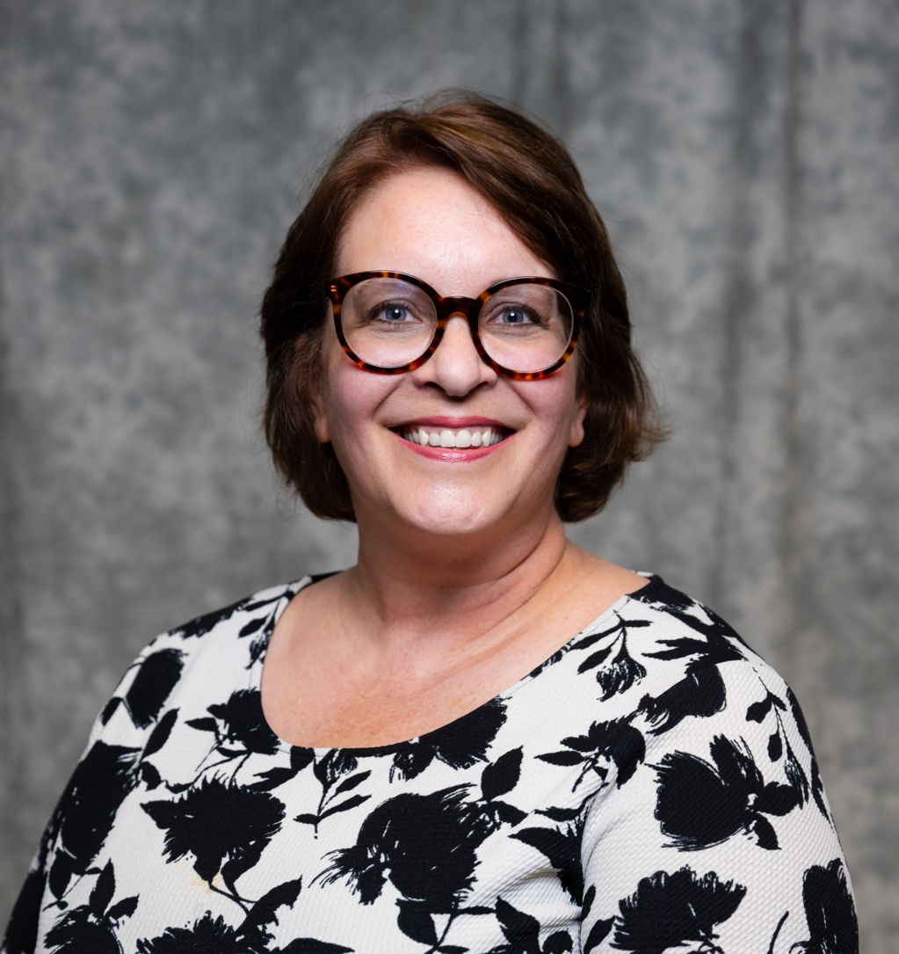

Figure 1 Dr. Kristine Morris as the new Dean and Director of the School of Nursing.

CSU Pueblo's School of Nursing is set to enter a new chapter with the appointment of Dr. Kristine Morris as its new dean and director. Morris begins her appointment on May 16, 2025. She brings a blend of academic leadership and extensive nursing education experience to the role.

“We are thrilled to welcome Dr. Morris,” said Provost Gail Mackin. “Her passion for nursing education, leadership, and innovation will bring fresh energy and vision to our program. I have no doubt that under her guidance our nursing g program will continue to grow and thrive. She will prepare the next generation of healthcare professionals to make a meaningful impact in our communities.”

Dr. Morris's expertise has been widely recognized in the field, earning her multiple accolades including two Cass Faculty Excellence Awards and [D Magazine's Excellence in Nursing Award in 2024](https://www.dmagazine.com/publications/d-magazine/2024/march/the-excellence-in-nursing-awards-2024/). As a Certified Nurse Educator (CNE) and active member of several professional organizations, including the American Nurses Association and Sigma Theta Tau International Nursing Honor Society, she maintains strong connections within the nursing education community.

Currently serving [as Interim Assistant Dean of Nursing at Texas Woman's University in Dallas](https://apps.twu.edu/my1cv/profile.aspx?type=twn&id=icpQc72h5QYKinaZHBW4Fw%3d%3d), Dr. Morris has demonstrated her commitment to expanding educational opportunities through her leadership of a $3 million Department of Education Title V grant focused on increasing access to baccalaureate nursing education. Her entrepreneurial approach to program development aligns perfectly with CSU-Pueblo's mission to grow and enhance its nursing programs.

Her academic credentials include a Ph.D. in Higher Education with an emphasis in Adult Teaching and Learning from the University of North Texas, complemented by a Master of Science in Nursing Education from Texas Woman's University and a Bachelor of Science in Nursing from Harding University.