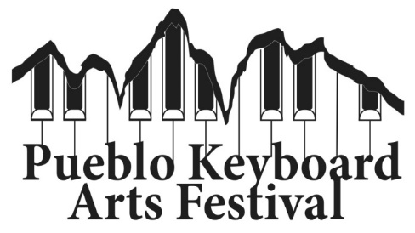
Dear Colleagues,

It is with great excitement that we at Colorado State University Pueblo look forward to the 14th annual Pueblo Keyboard Arts Festival, scheduled to take place Oct. 31-Nov. 2, 2024. Combining quality musical programs with educational opportunities for young and college age pianists, we hope to provide a welcoming platform for all interested in immersing themselves in the art of keyboard playing. It is my hope that participants and audience will find this Festival serves as a source of inspiration, knowledge, and one of the many elements that lead to the growth of the "complete musician."

The 2024 Festival offers a number of opportunities:
October 31, 7.00p.m. “Voices at the End” by composer John Psathas
A complete performance of this captivating digital concerto for six pianos, audio track, and video addressing issues of our planetary environmental future.
November 1, Masterclasses 6:00 p.m. to 8:00 p.m.
Open to High and Middle School Students.
November 2, PKAF Young Artist Competition, 9:00 a.m.
Offers cash prizes in the Junior and Senior, Solo and Ensemble divisions.
November 2, “Monster” Piano Concert, 7:00 p.m.
An all-piano extravaganza featuring faculty, guest artists from around the state, current CSU Pueblo students, alumni, and friends.
~
Please don't hesitate to contact us: Dr. Zahari Metchkov, zahari.metchkov@csupueblo.edu, 719-565-8855
Application form and information can be found at: www.zahari.metchkov.com/festivals

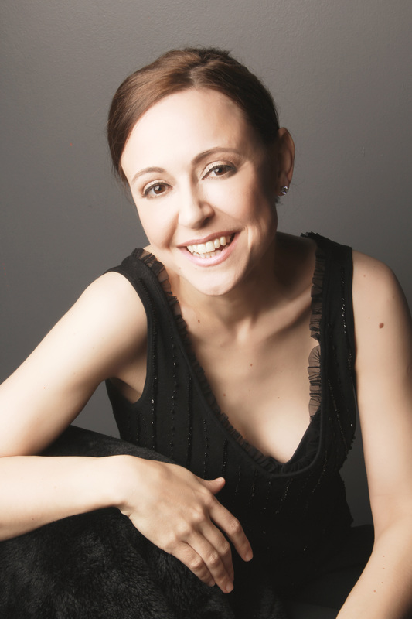
2024 FESTIVAL ARTISTS:
Petronel Milan, Guest Artist: "Formidable…dizzying…magical.” These words from New York reviewer Harris Goldsmith vividly illustrate pianist Petronel Malan’s uniquely captivating style. Indeed, as a multiple Grammy® nominee and gold medalist of several international piano competitions, Petronel continues to enthrall audiences worldwide. Lauded by reviewers as an unmistakably creative force in the classical music industry, Petronel’s critical acclaim culminated in the nomination of three Grammy® Awards, including “Best Instrumental Solo Album” for her debut disc Transfigured Bach.

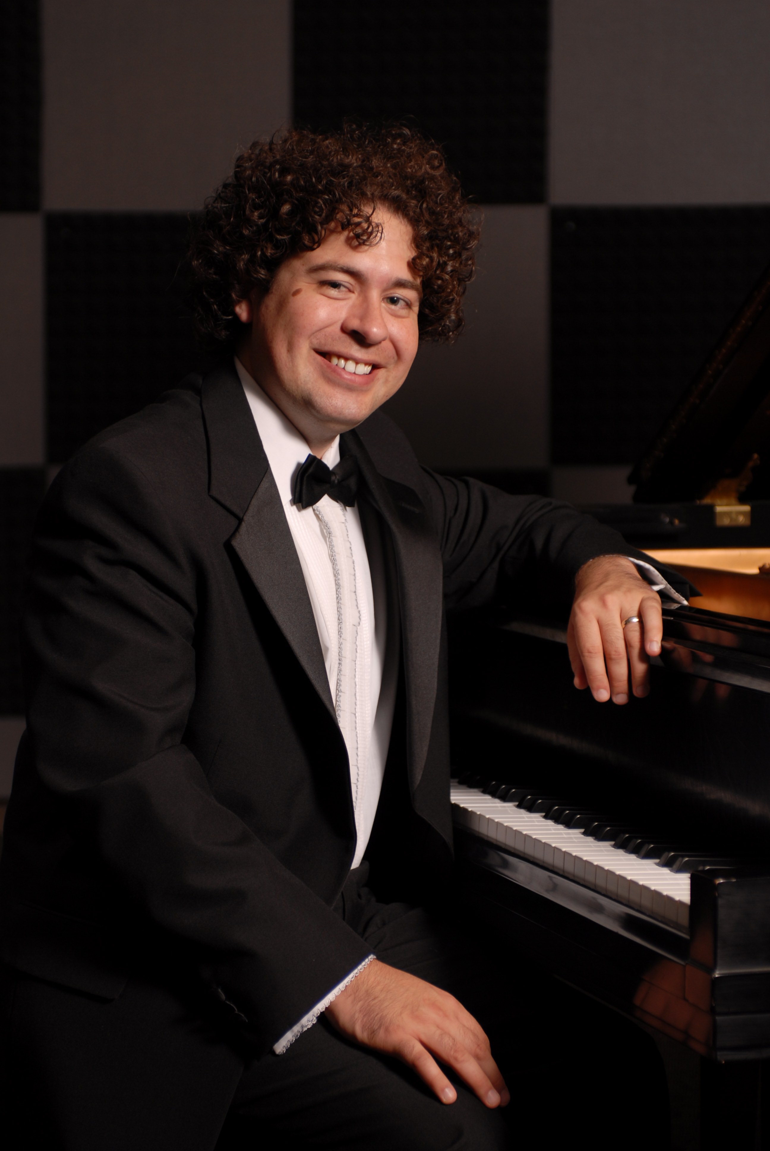
Michael Schneider, Guest Artist: Michael Schneider is a performing pianist, active collaborator, educating artist, and composer. Critics have hailed Michael as “a pianist with exceptional insight” and a “performer with great panache” in performances across the states and abroad. Michael holds degrees from the University of North Texas, where he studied with Dr. Pamela Mia Paul, and the Cleveland Institute of Music, studying with Mr. Paul Schenly. After two years as adjunct Professor of Piano at Youngstown State University in Ohio, he returned to Texas to study with Anton Nel at the University of Texas at Austin where he received his Doctorate of Music in May 2011. Dr. Schneider is owner, director, and teacher at “Master the Music” in Dallas, Texas.

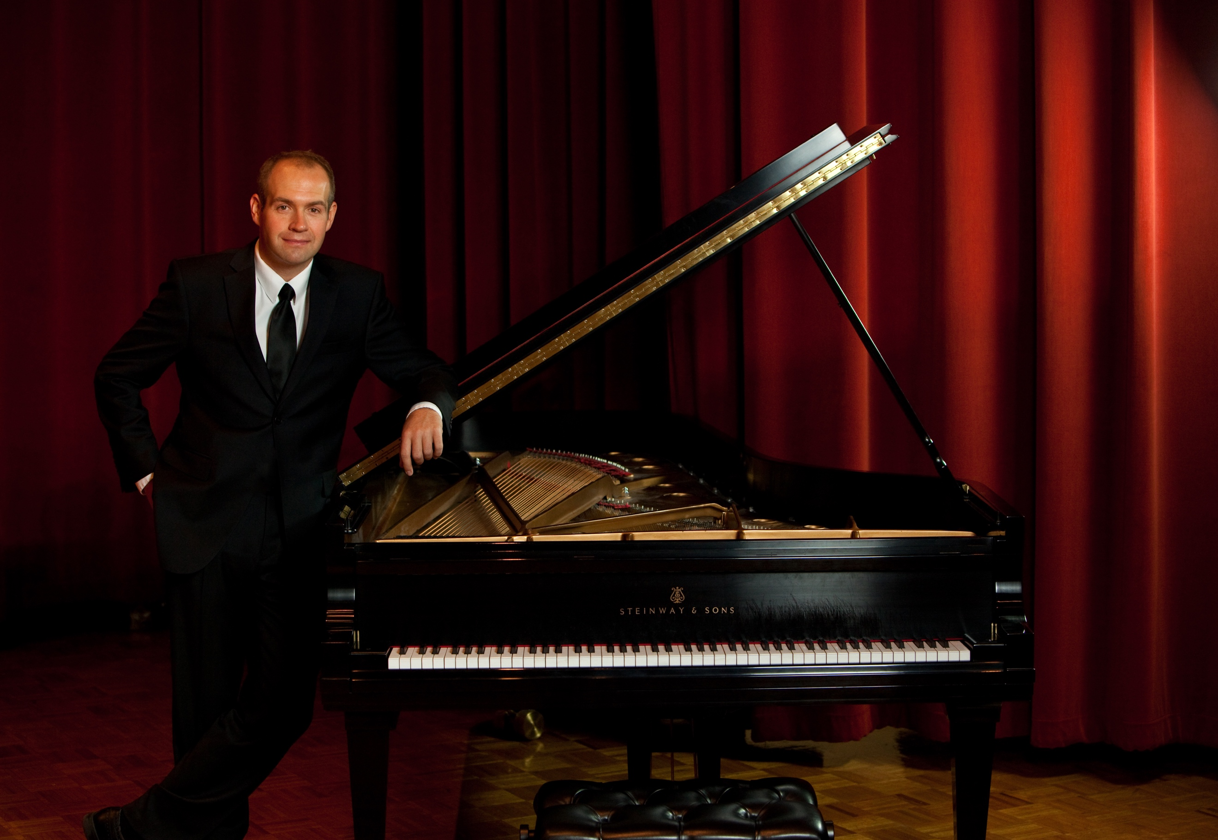
Zahari Metchkov, PKAF Artistic Director: Native of Sofia, Bulgaria, Dr. Metchkov is a Full Professor of Music at CSU Pueblo teaching applied piano, piano pedagogy, and ensembles. Zahari captivates audiences as a concerto soloist, recitalist, and chamber musician, maintaining multifaceted concert career. He has served for over decade the Colorado State MTA in a number of appointments, including President and VP for Conferences. Under his artistic leadership, Pueblo based non-profit “Piano Conversations” has delivered over 40 concerts in Southern Colorado cultivating appreciation for quality classical live performances. He holds BM, MM, and DMA in piano performance from the Cleveland Institute of Music, Cleveland, Ohio.

