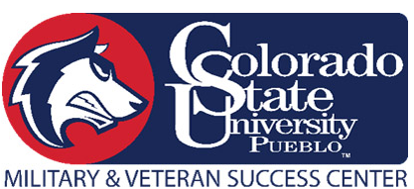

Colorado State University- Pueblo
Military and Veteran Success Center Scholarship Application
INFORMATION:

Last name First name M.I. Sex

Home
Cell
PID: Email address Phone number

Address Apt/Box number City & State Zip code

COMPONENT:
Army ARNG USAR Coast Guard
Navy Marine Corps Air Force

HIGHER EDUCATION:

Major: ______________________________

Expected Enrollment Status: Full-Time Part-Time Less than half-time

Anticipated Graduation Date: ___________________ G.P.A. _________________

PRIOR APPLICATION:

Have you previously received for the Veteran Scholarship? Yes No

If YES, in what semester were you awarded the scholarship? __________________________
(Note- You may only receive the MVSC scholarship one time)
CERTIFICATION

All the information provided in this application is true and completed to the best of the applicant’s knowledge.

Applicant’s Printed Name: _____________________________ Date: ______________________

Applicant’s Signature: ____________________________________

Scholarship Application Instruction: Spring 2022

Please read these instructions before completing your application. You must provide all information, including required documents, in order for the application to be deemed complete.

Eligibility:

Scholarships are awarded twice a year, (Fall and Spring). A new application and essay must be submitted each semester. You may only be awarded this scholarship once.

An applicant must:
- Be a U.S. Veteran, Active Duty Service Member, National Guard/Reserve Member or Dependent of a Veteran or Active Duty Service Member
- Enrolled Full-time
- Maintain 2.5 GPA per semester
- Submit an essay
  - Must submit an essay with a minimum of 500 words.

Essay Topic for Spring, 2022:

How has your experience with the military prepared you to be a successful student?

Required:

DEADLINE FOR SUBMISSION:
Your completed application must be submitted no later than December 1, 2021. Application and Essay can be emailed to laura.barela@csupueblo.edu or dropped off in the MVSC, located in the Occhiatto Student Center, Room 114

Submission including:
- Signed completed application
- Essay
- Veterans- DD214 or VA Certificate of Eligibility
- Dependents/Spouse- VA Certificate of Eligibility or Military ID

