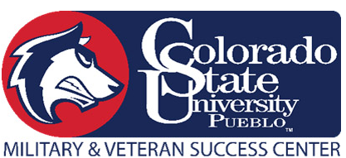

Colorado State University- Pueblo
Military and Veteran Success Center Scholarship Application
INFORMATION:

Last name First name M.I.

Home
Cell
Student Number: Email address Phone number

Address Apt/Box number City & State Zip code

Branch of Service: ___________________________________________________________________

HIGHER EDUCATION:

Major: ______________________________

Expected Enrollment Status: Full-Time Part-Time Less than half-time

Anticipated Graduation Date: ___________________ G.P.A. _________________

PRIOR APPLICATION:

Have you previously received for the Veteran Scholarship? Yes No

If YES, in what semester were you awarded the scholarship? __________________________
(Note- You may only receive the MVSC scholarship one time)
CERTIFICATION

All the information provided in this application is true and completed to the best of the applicant’s knowledge.

Applicant’s Signature: ____________________________________ Date: ______________________

Scholarship Application Instruction: Spring 2023

Please read these instructions before completing your application. You must provide all information, including required documents, in order for the application to be deemed complete.

Eligibility:

Scholarships are awarded twice a year, (Fall and Spring). A new application and essay must be submitted each semester. You may only be awarded this scholarship once.

An applicant must:
- Be a U.S. Veteran, Active Duty Service Member, National Guard/Reserve Member or Dependent of a Veteran or Active Duty Service Member
- Enrolled Full-time
- Maintain 2.5 GPA per semester
- Submit an essay
  - Must submit an essay with a minimum of 500 words.

Essay Topic for Spring, 2023:

How has your military experience impacted your perception of diversity and how has that prepared you for success in college?

Required:

DEADLINE FOR SUBMISSION:
Your completed application must be submitted no later than Monday, January 9th. Application and Essay can be emailed to veteransuccess@csupueblo.edu or dropped off in the MVSC, located in the Occhiato Student Center, Room 114.

Submission including:
- Signed completed application
- Essay
- Veterans- DD214 or VA Certificate of Eligibility
- Dependents/Spouse- VA Certificate of Eligibility or Military ID

