

# Monthly InfoSec Newsletter

### February 2021

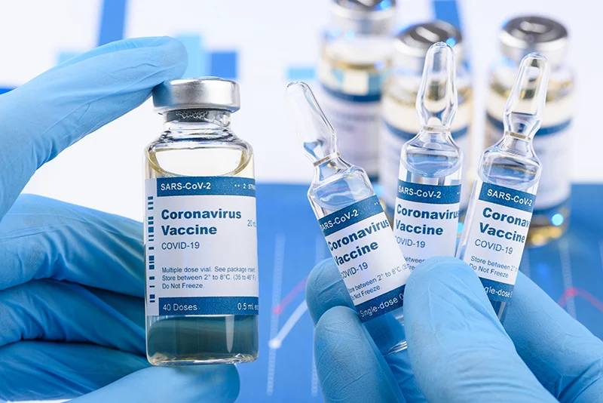

Cybersecurity Tips for February

**The 3 Greatest Valentine's Day Cyber Threats**

1. Phishing emails targeting online shoppers and daters.
2. Malware advertising mimicking legitimate websites.
3. Cyberattacks targeting point-of-sale devices.

**Vaccine systems targeted**

Tiberius is a software platform that was specifically developed for Operation Warp Speed — the collaborative effort led by the Department of Health and Human Services and the Defense Department to develop, manufacture and deliver safe and effective COVID-19 vaccines to Americans.  Russian hackers are targeting hundreds of US hospitals and healthcare providers just as the coronavirus is making a comeback, officials from three government agencies and the private sector are warning. Hackers are attacking the cooling solutions for the vaccine. The Pfizer vaccine needs to be stored at -94 degrees which means that the storage and transport is essential in keeping it effective. IBM has been helping the government track these attacks and they have stated that the attacks have most likely come from another nation-state, and have linked Russia, China, and North Korea to attacks on COVID-19 vaccine developers. The Department of Homeland Security has stated that organizations are being targeted but individuals should also be aware of these attacks, so they aren’t victim to them.

**NEW! Campus Information Security Working Group**

This month we would like to bring your attention to a new cybersecurity group on our CSU Pueblo campus, the **Information Security Working Group** (ISWG). This group consists of CSU Pueblo faculty and staff and each team member is designated as their department point of contact when a Cybersecurity incident occurs.

Members will help develop a long-term security vision for the campus, raise awareness for staying safe at work and home, help identify our campus’ critical systems, and provide information security/cybersecurity recommendations.

Please let us know what you thought of the newsletter and any topics you would like to see in a future issue. Please send all ideas or comments to [infosec@csupueblo.edu](mailto:infosec@csupueblo.edu)



**Campus InfoSec Stats**

January 2021

Phishing Email = 14

Serious Spam Emails = 2

January 18 – 24, 2021

Total Email: 84544 Total

Total Rejection Count: 15233