**Hasan School of Business Harlaxton Summer Program**

**Study Marketing at Harlaxton Manor, England**

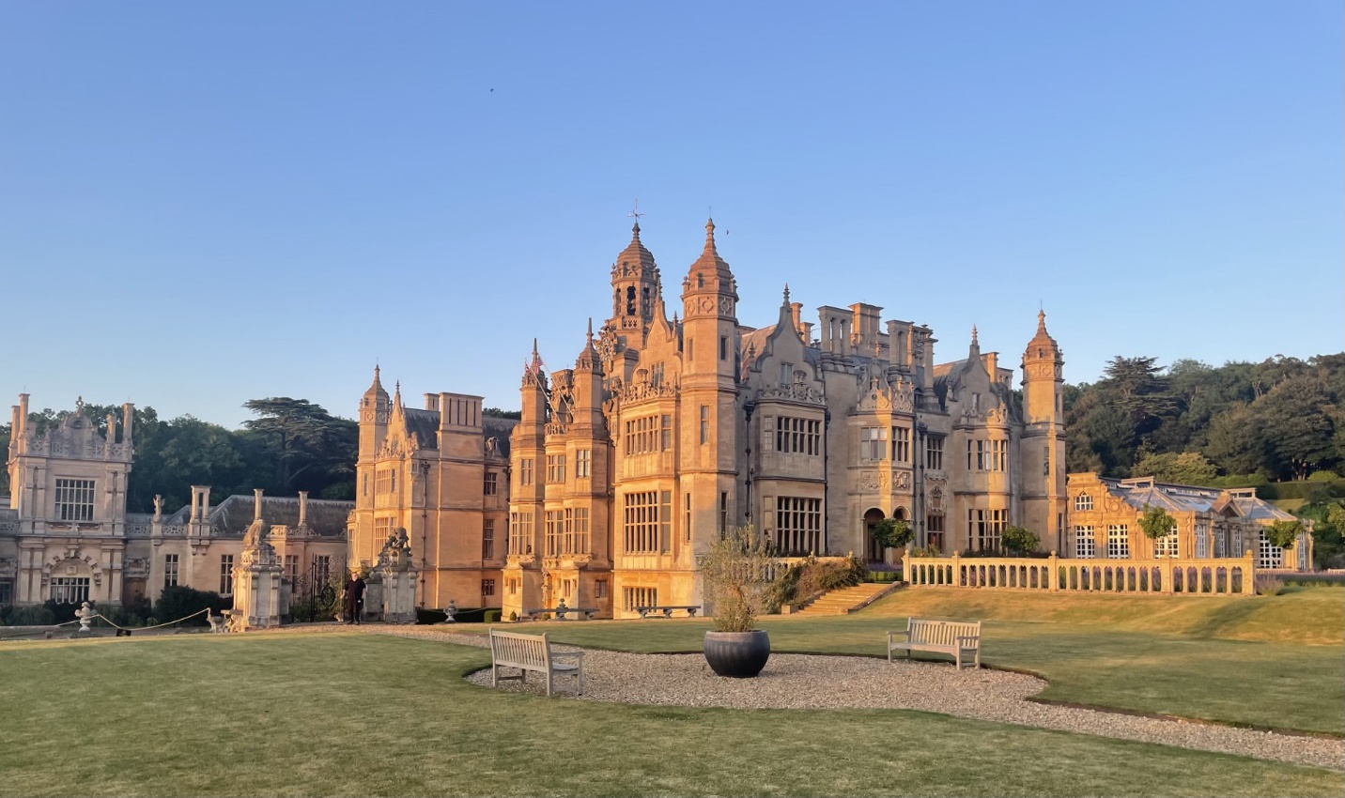

**Study and Stay at Harlaxton Manor**

**Harlaxton Manor is located near Grantham--about 1hour by train from London**

 In summer 2025, students from the CSU System (CSU and CSU-Pueblo) may take two marketing courses with Dr. Ian Brennan at Harlaxton College, England. These courses (MKTG348 and MKTG342) transfer as MKT361 (Buyer Behavior) and MKT320 (Integrated Marketing Communications) at CSU. Students study and reside at Harlaxton College, Grantham--a Victorian manor about an hour by train from London. **Best College Reviews rates Harlaxton College as the best study-abroad program in the world\*** [www.bestcollegereviews.org/best-study-abroad-programs/](http://www.bestcollegereviews.org/best-study-abroad-programs/)

CSU-Pueblo students applying for the Harlaxton Program may apply for a scholarship supported by   
Canvas Credit Union



**The Harlaxton Program Fee includes:**

****\*Full room and board--- three weeks (M-F) accommodation and meals at Harlaxton College. Packed lunches for students who participate in field trips, **and group dinners in British cities when a field trip does not permit dinner to be taken at Harlaxton.**  
*Faculty-led tour of Harlaxton’s secret doors, rooms and passageways!

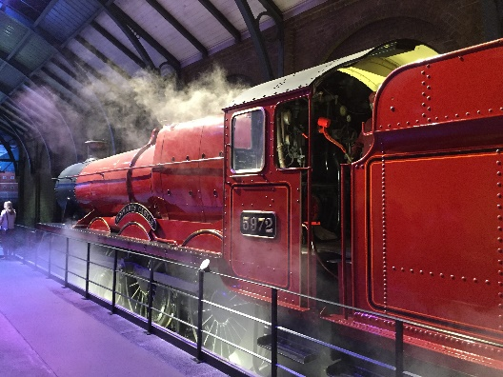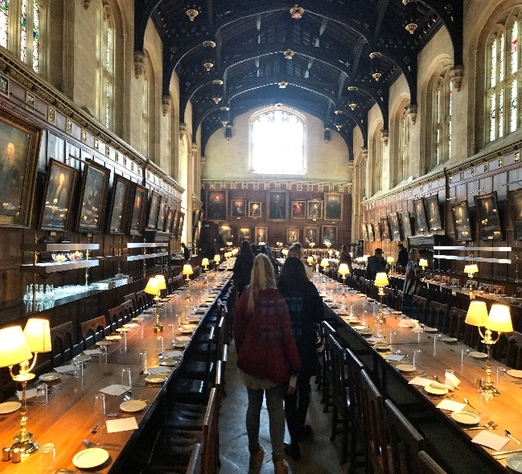* A 3 day London pass with free entry at more than 50 London attractions --including the Tower of London, the Thames River Cruise, Sherlock Escape Room, Westminster Abbey, the Tower Bridge Experience, the London Bridge Experience, Windsor Castle (location of the wedding of Prince Harry and Meghan Markle), Shakespeare’s Globe Theater, Kensington Palace, the Wimbledon Tennis tour, Wembley (the English national soccer stadium), Chelsea soccer stadium, London’s 2012 Olympic Stadium, The Shard (Europe’s tallest building), the Queen’s Gallery, Kensington Palace, Hampton Court Palace, and a hop-on-hop-off London bus tour. Note most London art galleries and museums have free entry (e.g., British Museum, National Gallery, Victoria and Albert Museum)

*A taxi service to and from Harlaxton College to the local train station (Grantham). London is an hour by train from Grantham, and the trains run almost every hour between Grantham and London.

* A 22-day BritRail pass (allows students to travel by train to any town or city on the UK rail network)

* London Underground (“The Tube”) Oyster pass

*Faculty led tour of London

* London Theater (Agatha Christie’s Witness for the Prosecution) at County Hall

*Events in York

*Cambridge punting (boat) tour

*Faculty chaperoned weekend trip to Salisbury (for the Roman Baths in Bath, Salisbury Cathedral, Stonehenge and Mottisfont) with accommodation & breakfast/dinner included.

*Faculty chaperoned weekend trip to Bournemouth (hop-0n-hop-off bus and boat trip down the Dorset Coast to Poole and Old Harry’s Rock) with accommodation & breakfast/dinner included.

*Faculty-led BritRail trips to London (several days), Cambridge, and York-- and locally near Harlaxton.   
*Use of Harlaxton College gardens, sports facilities, computers, laundry and library.  
*The program fee excludes the flight (USA-London)

**HALAXTON HISTORY** Harlaxton Manor was built in 1832. Harlaxton’s use as a stately home was interrupted during World War I when it housed the Royal Flying Corps—the predecessor of the Royal Air force. It was acquired in the late 1920s by the flamboyant entrepreneur Violet Van Der Elst who developed the world’s first brushless shaving cream. RAF Harlaxton was reactivated during World War II when the manor housed the 1st Airborne. Harlaxton was first used as a study-abroad facility in the 1960s by Stanford University. In 1971 the University of Evansville began offering study abroad programs at Harlaxton—programs that have run uninterrupted for more than fifty years. The Colorado State University System began offering a study-abroad summer program at Harlaxton in 2016.   
**HARLAXTON IN THE MOVIES** Harlaxton has been featured in a number of movies and television programs including *Citadel (2023),* *The Secret Garden* (2020), V*ictoria* (2017), *The Haunting* (1999), *The Lady and the Highwayman* (1989), *The Last Days of Patton* (1986), and *The Ruling Class* (1972). Here is the complete list from the [IMD database](https://www.imdb.com/search/title/?locations=Harlaxton+Manor%2C+Harlaxton%2C+Lincolnshire%2C+England%2C+UK)

**ACADEMICS** Students from the CSU System (CSU and CSU-Pueblo) take two marketing courses (MKTG 348 Consumer Behavior and MKTG 342 Promotional Strategy) with Dr. Ian Brennan at Harlaxton College, England. Dr. 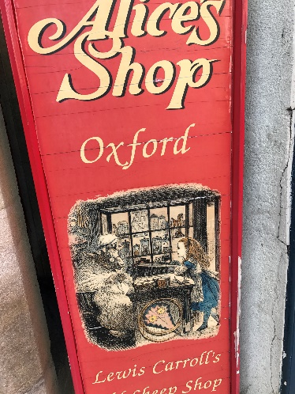Brennan was previously a member of the resident British faculty at Harlaxton College. He is professor of marketing at CSU-Pueblo, and he has led the study abroad programs at Harlaxton from their inception in in 2016. Students will begin each course on **May 23**. Two weeks of online coursework (prior to arrival in England on **June 9** ) will be followed by three ****weeks of face-to-face instruction at Harlaxton College, England. Students will leave Harlaxton on **June 30--** eitherto return to the USA or to continue their travels in Europe. An online Final Exam must be completed after returning from Harlaxton.

The **MKTG 348/ MKT 361** course will focus on understanding consumer decision-making. We will examine recent insights generated from the field of behavioral economics. In the past students have visited the Behavioral Insights Unit—an organization partly owned by the UK Government—for a talk on recent field experiments carried out by the Behavioral Insights Team.

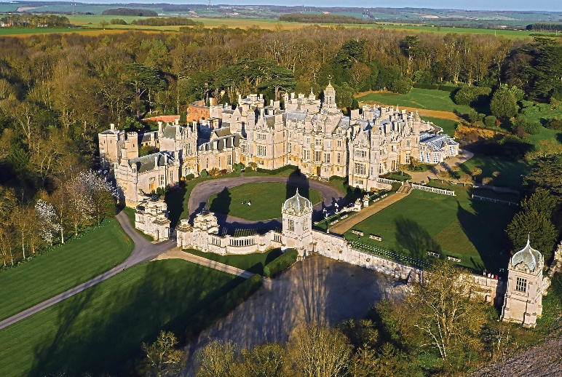The **MKTG 342/ MKT 320** course will draw heavily upon use the World Advertising Research Center (WARC) database. WARC is a collection of best practice articles and award winning advertising campaigns from around the world, with a particular emphasis on British advertising case studies. Research by Peter Field (2014) indicates that creatively- awarded advertising campaigns in the WARC database achieve significantly greater business results. Accordingly, in addition to traditional course content, the MKTG 342 course will incorporate creativity exercises both inside and outside the classroom.

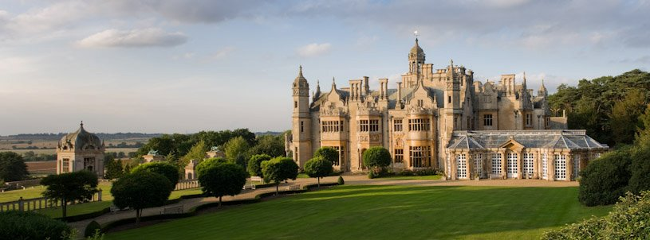**CONTACT INFORMATION**[Ian.brennan@csupueblo.edu](mailto:Ian.brennan@csupueblo.edu)  
**Harlaxton Program Leader**   
  
“**Harlaxton** has to be seen to be believed and even when one has seen it, it is not always easy to believe it” - **Mark Girouard**—*The Victorian Country House.*

[Natalie.Cartwright@colostate.edu](mailto:Natalie.Cartwright@colostate.edu)  
[Aimee.Jones@colostate.edu](mailto:Aimee.Jones@colostate.edu)