TMA Work Order Request
The Physical Plant has recently updated the TMA system to better manage CSU-Pueblo Work Orders and Maintenance Requests. Through this update, any campus stakeholder can submit a work order request or query the status of current work orders.
TMA is most easily accessed through the Facilities Management homepage which can be found under the About tab on any CSU-Pueblo webpage.
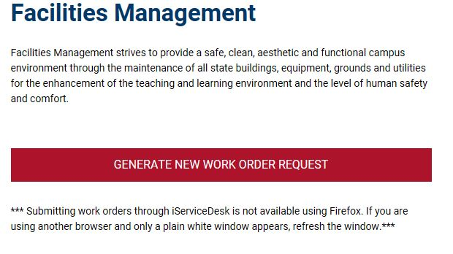
Click here!

On the TMA site, the Navigation menu in the left margin has several options which allow any user to submit a request or to query the status of requests or work orders.
Click here!

In order to submit a request, you are required to fill in all red fields. You can also attach a document or picture.
To create a Desktop Shortcut
Save the TMA iServiceDesk Work Request screen as a Favorite.
Then you can drag the Bookmark to the Desktop.
